|  |  |
| --- | --- |
|  | Student Name _______________________    **Eastern Goldfields College**  Mathematics U1 2019  Test 2 – Calculator Free1 |
|  |  |

**Time allowed: 15 minutes** Total Marks: 14 marks

**No calculator or notes permitted for this section.**

Question 1 [2 marks]

Which of the following statements are true for triangle ABC right-angled at C. (Circle your answer)

1. a2 = b2 + c2 ii) a2 = b2 – c2 iii) b2 = a2 – c2

iv) b2 + a2 = c2 v) c2 – a2 = b2 vi) a2 + c2 = b2

Question 2 [2 marks]

Two hikers, Amy & Erin, set off from base camp. Amy walks 12 km due east and Erin walks 9 km due north. Determine the shortest distance between Amy and Erin.

Question 3 [2 marks]

A triangular prism has dimensions x, y and z cm, as shown. Write a simplified algebraic expression for the surface area of this prism.

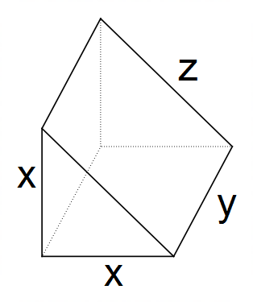

Question 4 [8 marks : 2, 2, 2, 2]

1. Calculate the volume of this trapezoidal prism.

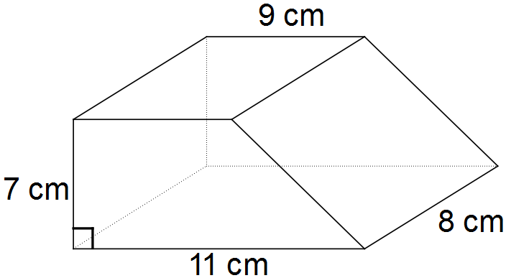

1. An equilateral triangle has sides of length 10cm. What is the perpendicular height of this triangle? Give your answer to the nearest cm.

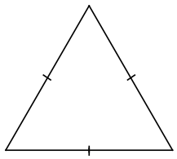

1. Calculate the exact perimeter of a quadrant of a circle with radius 12 cm.

*Leave your answer in terms of $π .$*

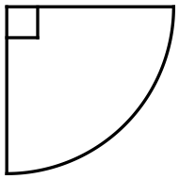

1. A circular spinner has an area of 630 cm2. The area of the shaded section is 70 cm2.

What is the size of the angle marked x?

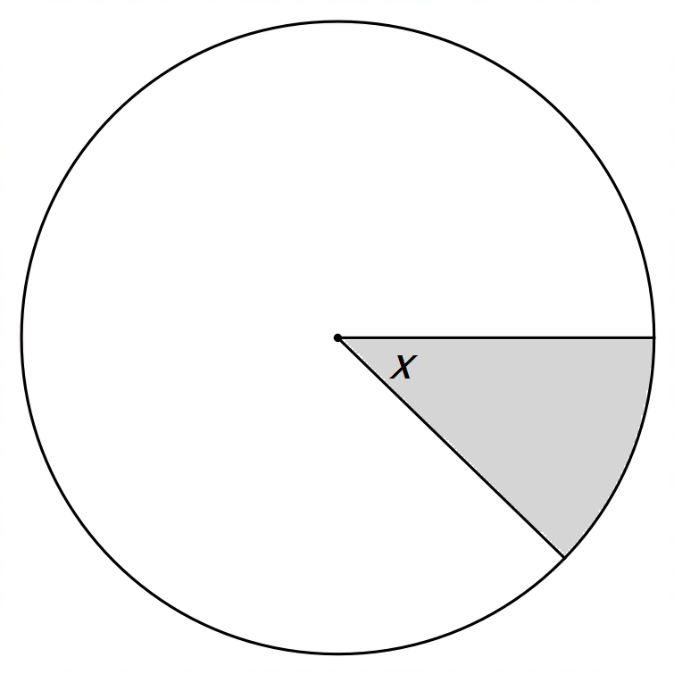

End of Calculator Free Section

|  |  |
| --- | --- |
|  | Student Name _______________________    **Eastern Goldfields College**  Mathematics U1 2019  Test 2 – Calculator Assumed  Notes and calculator permitted1 |
|  |  |

**Time allowed: 35 minutes** Total Marks: 32 marks

Question 5 [4 marks: 2, 2]

A rectangular shoe box has dimensions 31 cm, 16 cm and 11 cm.

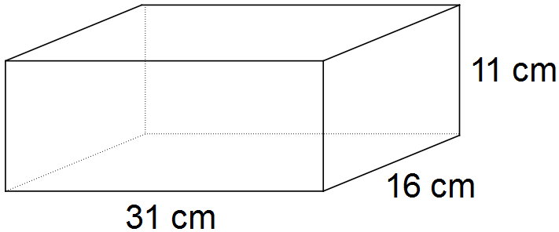

1. Calculate the length of the diagonal across the base, to the nearest mm.
2. Calculate the length of the longest diagonal, to the nearest mm.

Question 6 [6 marks]

Marco wishes to invest $1,200 for 8 years. The following investment opportunities are available:

1. Compound interest at 8.5% p.a. compounding annually.
2. Compound interest at 8.25% p.a. compounding monthly.

Which investment plan should he choose to maximize the interest earned? Show full working to justify your answer.

Question 7 [4 marks]

Calculate the surface area of the following cone with a hemispherical lid.

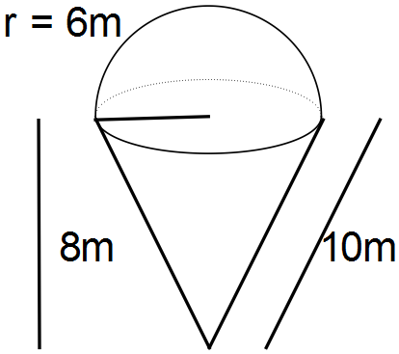

The cone has a radius of 6m, vertical height of 8m and a slant height of 10m.

*Give answer to nearest square metre.*

Question 8 [4 marks]

A solid cube of stainless steel is to be melted down and made into spherical ball bearings of radius 6 mm. The cube has 50 cm edges.

How many ball bearings can be made, assuming that there will be 5% wastage in the manufacturing process? *Show all your working.*

Question 9 [9 marks: 2, 3, 2, 2]

A cylindrical concrete pipe of length 2400 mm has an external diameter of 300 mm.

The concrete is 40mm thick.

Calculate, showing all your working:

1. The surface area of the outer curved wall. *Give answer to nearest cm2.*

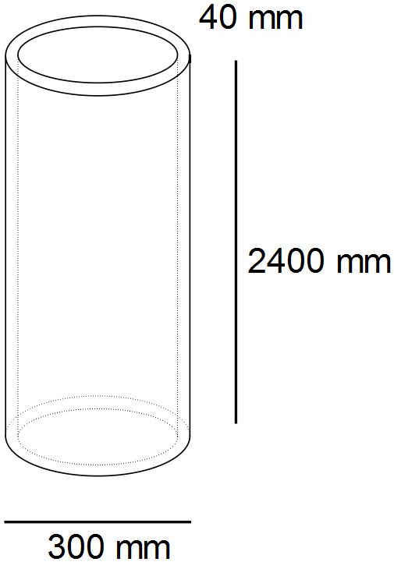

1. The area of the shaded top annulus ring of the pipe.

*Give answer to nearest cm2.*

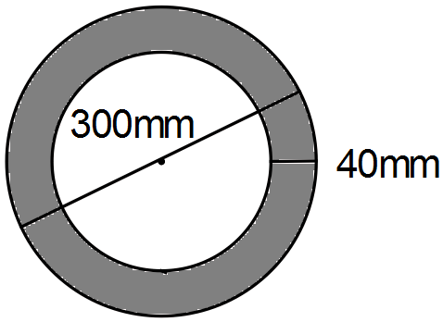

1. The volume of concrete required to make the pipe. *Give answer to nearest cm3.*
2. How many cubic metres of concrete are required to make 100 of these pipes?

*Round answer up to the nearest m3.*

Question 10 [5 marks]

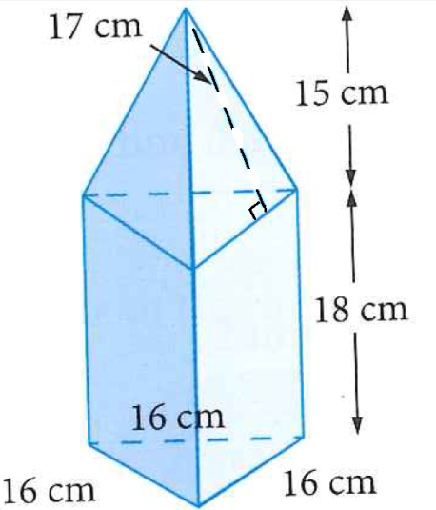This foam structure is part of a child’s toy. The dimensions are shown in the diagram on the right. It consists of two sections: a triangular pyramid and a triangular prism sewn together. The faces need to be covered in fabric. Calculate the total amount of fabric required to completely cover the outside of this foam structure.

End of Calculator Assumed Section